Video Game hook and Inspiration.

Hook:

Lucifer, the Lord of Hell, throws you – his son/daughter – out of the house and sends you to live in Limbo. Now you must battle back through the levels of hell, defeating and collecting horrifying and grotesque creatures along the way, to make it back to Lucifer and prove you are worthy of the Throne by defeating your father in Hellish combat.

Game Inspiration:

Parody of Pokemon: Fire Red. (or really any pokemon game)

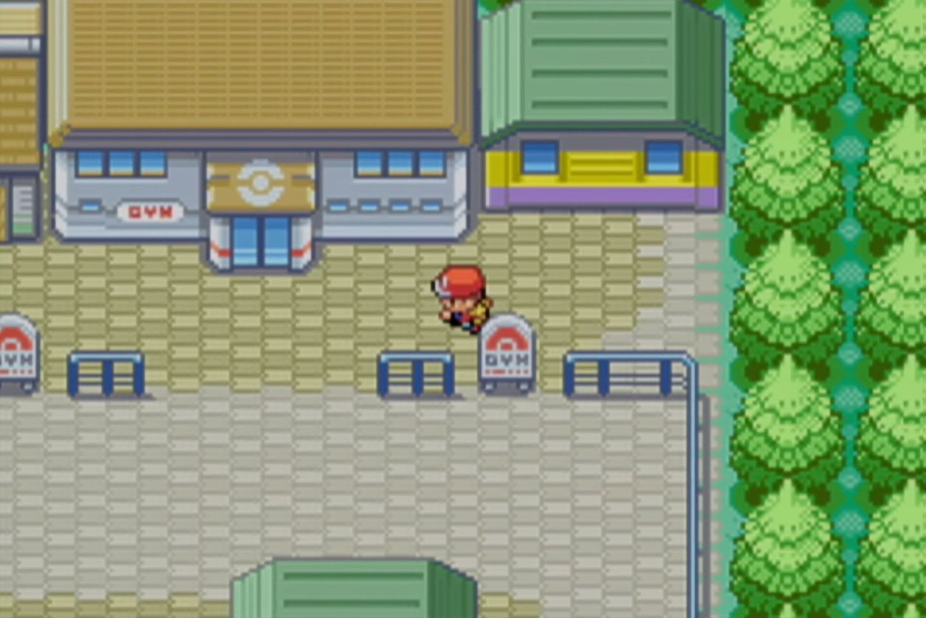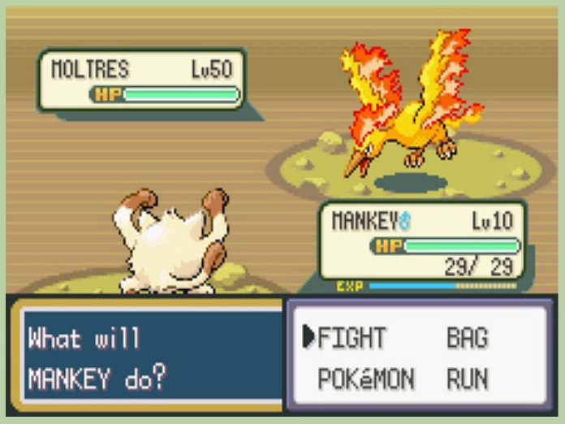The base game will feel most similar to a pokemon game. You will travel around somewhat static zones of the world/map, with lots of people and things to interact with that will flesh out the world and mission objectives for you. You will have an inventory system where you keep all your items and monsters, and a battle party that will fight for you in battle instances.

Horror inspo from games such as:

Dark Souls

Binding of Issac

Undertale

I want the atmosphere and world to feel dark and eerie and horrific, disturbing. I really want to lean into this, more for comedic purposes than wanting an actually dark game. I want to push this aspect to the extreme because I also want the characters and dialogue to feel more light hearted and casual, as if the horror of hell is normal and just their everyday lives (which of course it is).

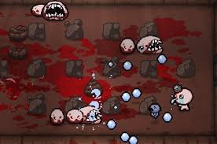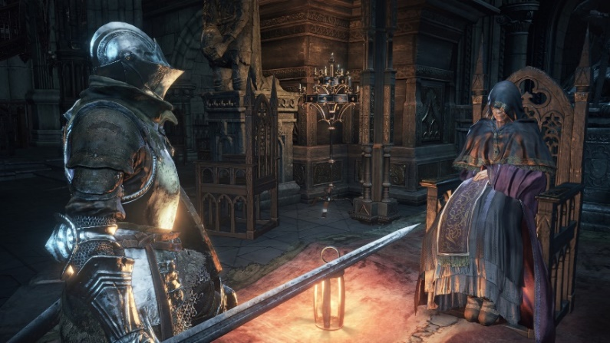

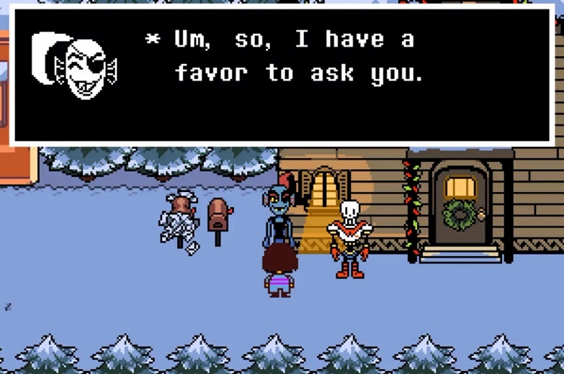

Some Battle Elements inspiration from:

Chrono Trigger

Pokemon

Final Fantasy

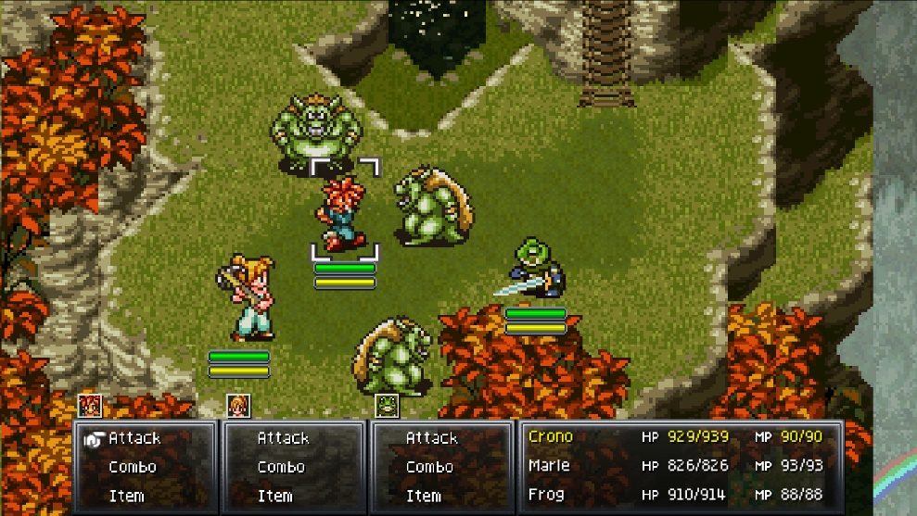I want the battle to feel most like pokemon battle instances, with a few key differences. I want your party to battle together, rather than one at a time. This means a smaller party, smaller move sets, but powerful combos between your party members. Building a successful party will be the key to progressing through the game, and finding more powerful combos between monsters you collect.

Coding Help from this playlist perhaps?

<https://www.youtube.com/watch?v=_PagngtnZ3U>

plus this one too from brackeyes

<https://www.youtube.com/watch?v=_1pz_ohupPs>